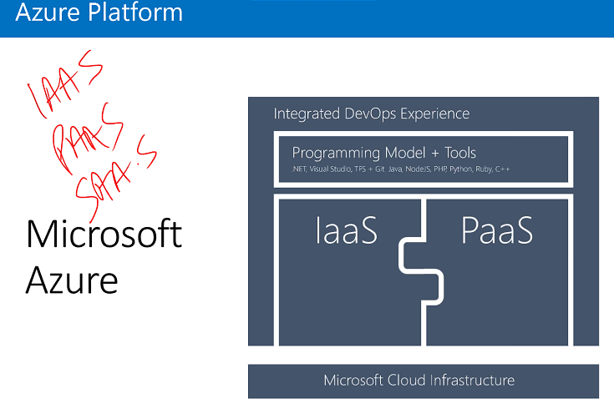

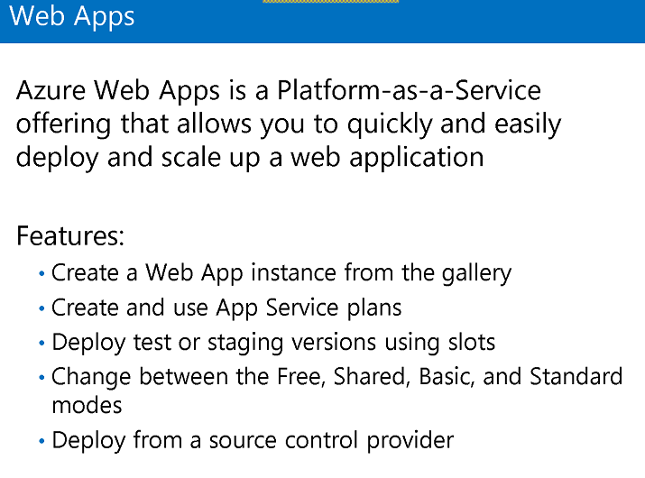

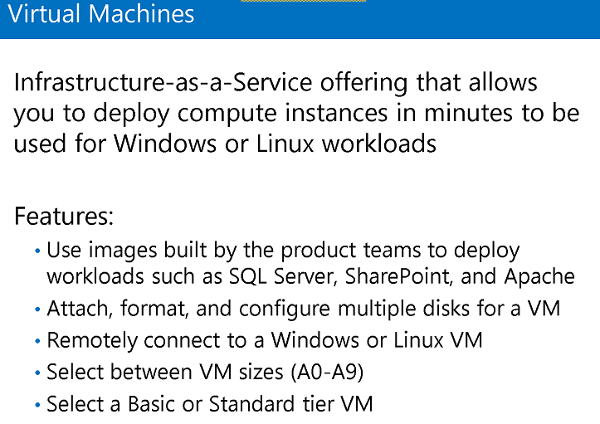

Resource group is a unit where everything resides. It’s a collection of resources.

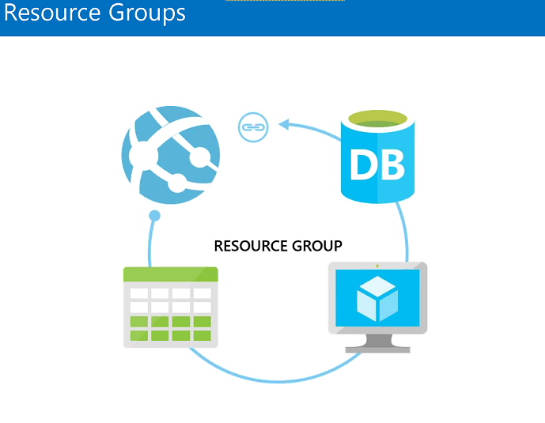

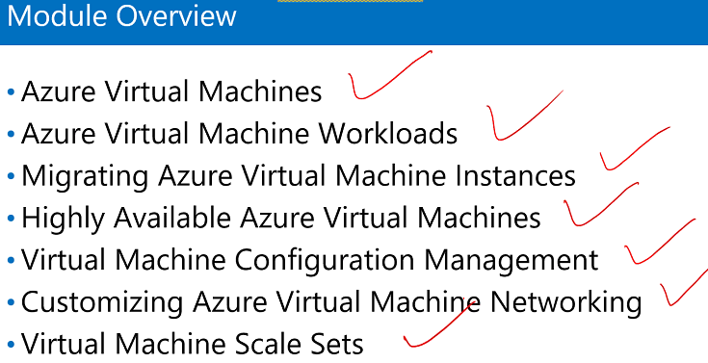

VM Composition

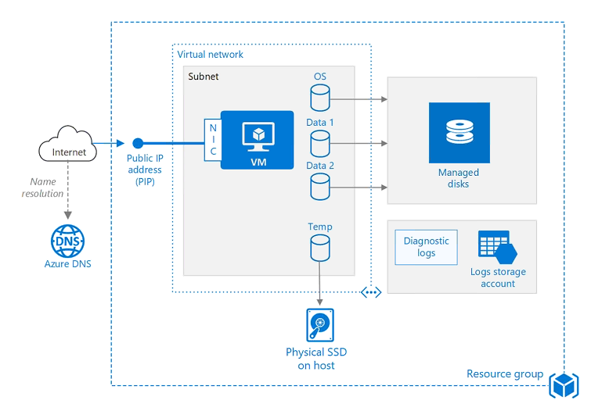

VM will save the information on storage account, OS is saved, and data is saved. Storage account (managed and unmanaged), there is one storage account which stores log files, and another for page file. Page file is a temp storage where memory content is loaded.

Cpu-memeory-HDD –page file-memory-CPU

NIC adapter attached to VM to connect to network.

VM is assigned with public IP and private IP(internal connection)

Solid state drive – SSD

Hard Disk Drive – HDD

Subnet is a smaller unit of bigger network

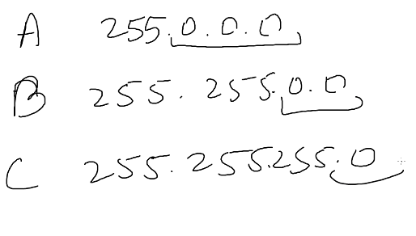

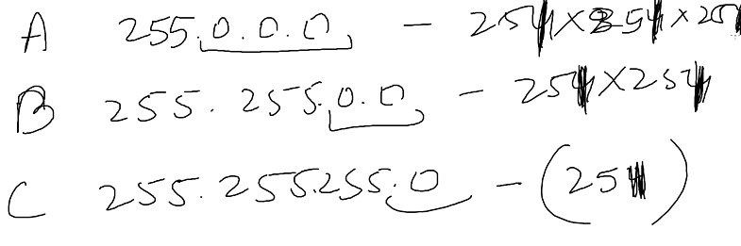

With azure – 5 are reserved with azure.

We create different subnet for different application.

Extension – scripts which we run while deploying app

**Upload A vdh**

1. Create a VHD
2. Upload in storage

If we want sever to use same network then keep in same resource.

**Scale set**

1. Create VM Scale set (Horizontal)

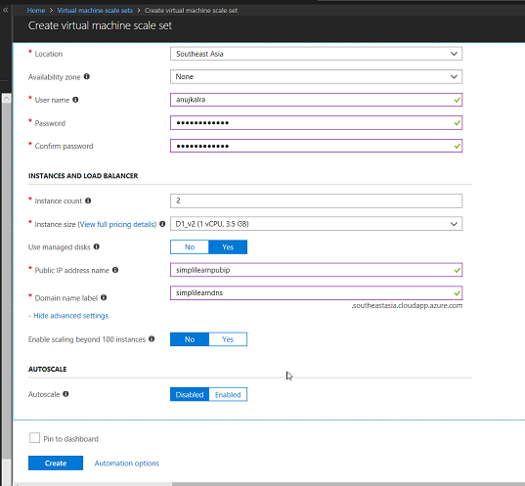

1. Select vm(Vertical)
2. Select size

**How do we scale a scale set**

**This is horizontal scaling**

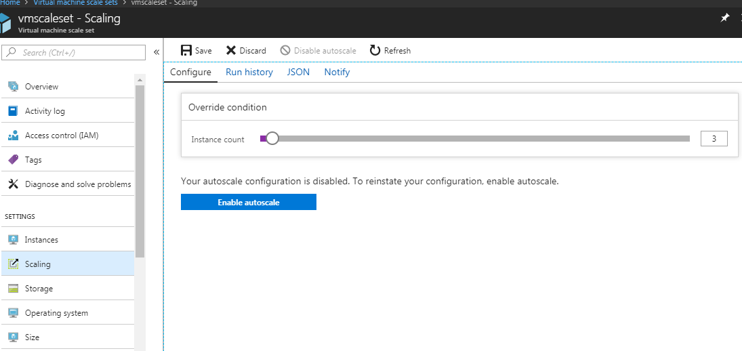

**This is vertical scaling**

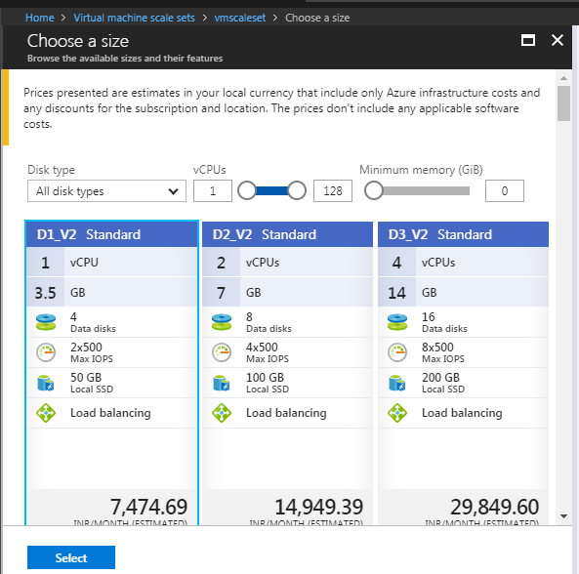

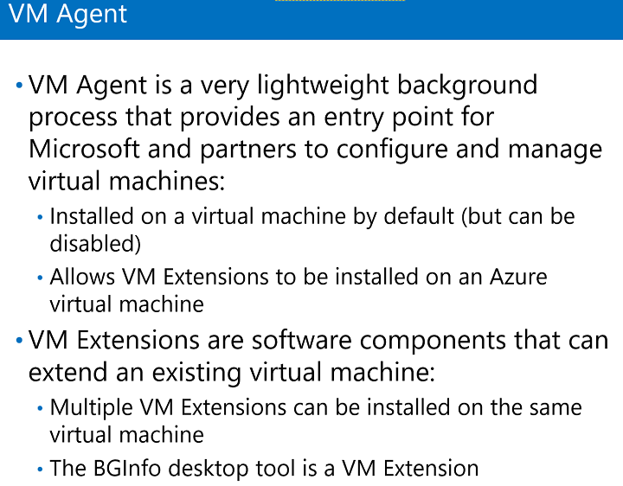

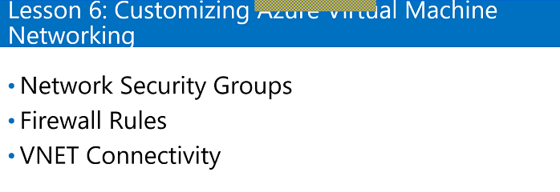

NSG is like fairwall that no one will cross. Can block the port which we don’t want to give access.

How to set NSG rule:

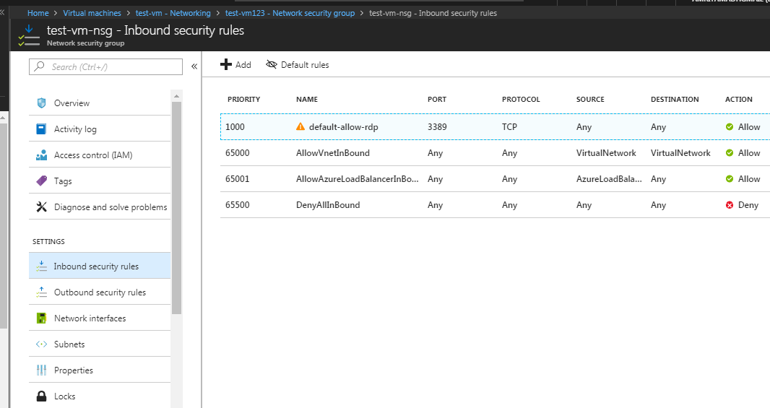

Edit one rule:

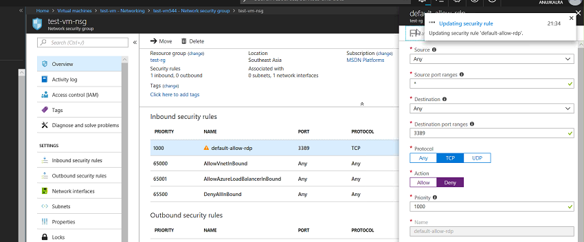

Got to vm

Click connect

If it is deny, it will not allow us to connect.

